Testing Example – smfkibb_tbl_security

COM_T

Step 1a: insert dummy record
insert into table com.t_smfkibb_tbl_security (security_id, security_code, record_status, record_created_date, record_updated_date, etl_dt, etl_timestamp)
select 0, 'TEST', 'A', current_timestamp(), current_timestamp(), '20260114', current_timestamp();

step 1b: insert 1 record from raw with modify value
insert into table com.t_smfkibb_tbl_security
select Security_Id
, Parent_Security_Id
, '0053.MYY' Security_Code --modified value
, Exchange_Security_Code
, External_Security_Code
, Exchange_Old_Security_Code
, Bloomberg_Security_Code
, Reuters_Security_Code
, ISIN
, Sedol1
, Sedol2
, Security_Name
, Security_Short_Name
, Instrument_Type_Id
, Security_Type
, Security_Ccy
, Security_Margin_Code
, Market_Id
, Country_of_Incorporation
, Listing_Date
, Delisted_Date
, Suspension_Date
, Suspension_Flag
, Expiry_Date
, Review_Date
, Price_Rollover
, Parent_Security_Code
, Halted_Date
, Provisional_Security
, Issuer_Type
, Issuer_Bloomberg_Security_Code
, Issuer_Market
, Insured_Name
, Beneficiary_Name
, Insurance_Company_Id
, Policy_Number
, Insurance_Policy_Type_Id
, Policy_Date
, Policy_Effective_Date
, Sum_Assured
, Security_Group_Code
, Bank_Id
, Receipt_Number
, Tenure_Month
, Maturity_Date
, Remarks
, Record_Status_Id
, Update_Record_Id
, Created_By
, Created_Datetime
, Last_Updated_By
, Last_Updated_Datetime
, Deleted_By
, Deleted_Datetime
, Authorized_By
, Authorized_Datetime
, Post_Reviewed_1_By
, Post_Reviewed_1_Datetime
, Post_Reviewed_2_By
, Post_Reviewed_2_Datetime
, Reviewed_By
, Reviewed_Datetime
, System_Updated_Datetime
, Board_Lot_Size
, Share_Category
, Price_Date
, Price_Ccy
, Price
, Account_Id
, Is_Third_Party_Security
, Third_Party_Security_Provider_Account_Id
, Settlement_Agent_Id
, Settlement_Account_Id
, Board_Id
, Sector_Id
, Issued_Shares
, StockStatus_Id
, PG_Indicator
, Reference_Price
, Syariah_Stock_Indicator
, Is_Index_Counter
,'A', current_timestamp(), current_timestamp(), '20260114', current_timestamp()
from raw.smfkibb_tbl_security
where etl_dt = '20251209' and security_id = 1 ;

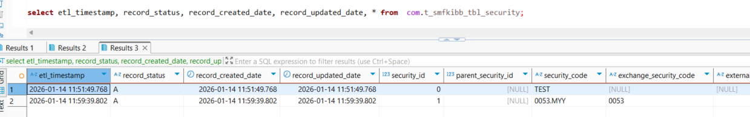

Step 2: Run COM_T script to test the logic
Expected result:
- Security_id = 0 – following fields shall be updated:
  - Record_status = X
  - Record_updated_date = script execution datetime
  - Etl_timestamp = script execution datetime
- Security_id = 1
  - security_code = shall be updated according to source
  - Record_updated_date = script execution datetime
- Rest of the records – shall be newly inserted to com_t table
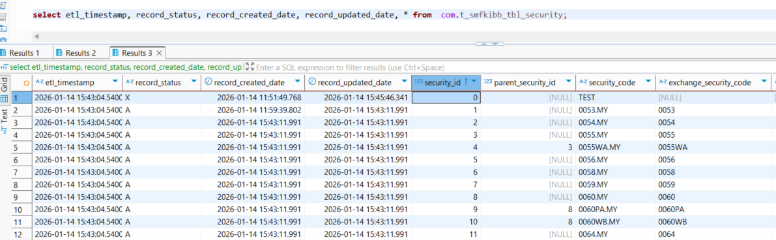

Outcome: expected result matching actual result

Step 3: High level comparison with source
Source db
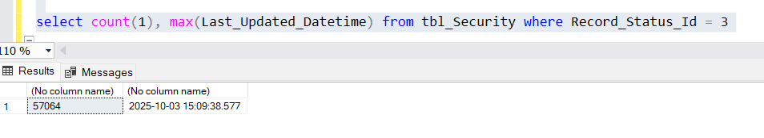
Data Lake
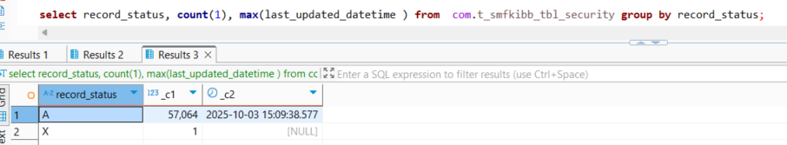

Outcome: result matching

